**Your Challenges:**

1. By referring to the SVG04.html provided, your will realized that there will be a problem when you drag the object too fast. In this challenge, you need to perform the following
   * Solve the abovementioned problem
   * Provide multiple rectangles, allow user drag any one of them

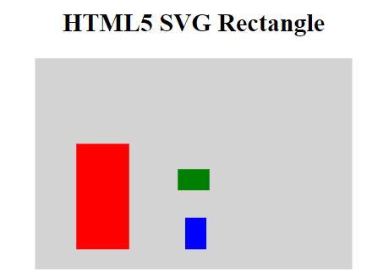

1. Continue from previous challenge, you are required to create the following solution using jQuery to allow user dynamically add new rectangle with button click. The example of design as follow:

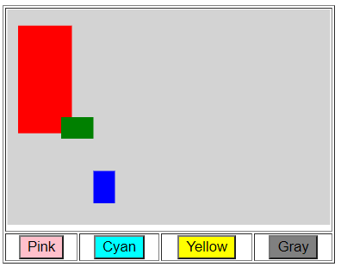

1. Create an interface a below:

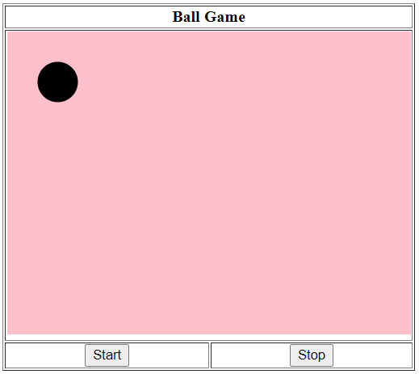

When user click the Start button, the circle will move. And while circle is moving, if user click Stop button, the circle will stop.

The circle will move in 360o. When hit the any of the 4 edges, it will bound bounce back.

You can use either pure JavaScript or jQuery for this challenge.